Martin Ballesta
Scotia Airlines assessment HND
Object oriented programming

General description:
The application we have to make in JAVA is a flight booking system for an airline called Scotia Airlines.
The application will cover flight bookings, the information related to those flights and its payment.
A flight can be in any of the following states:
1.Available for booking,.

2.Checking in, at this stage the flight can be cancelled or booked but not reserved.

3.Boarding, at this stage no reservations or bookings can be made.

4.Closed, at this stage no reservations or bookings can be made.

Booked seats cannot be refunded, but it can be re-sold.

The company has a discount scheme:
1.Western Isles residents get a 10% discount.

2.Business travellers get 25% discount.

3.Ordinary passengers have 5% discount.

Class Diagram:
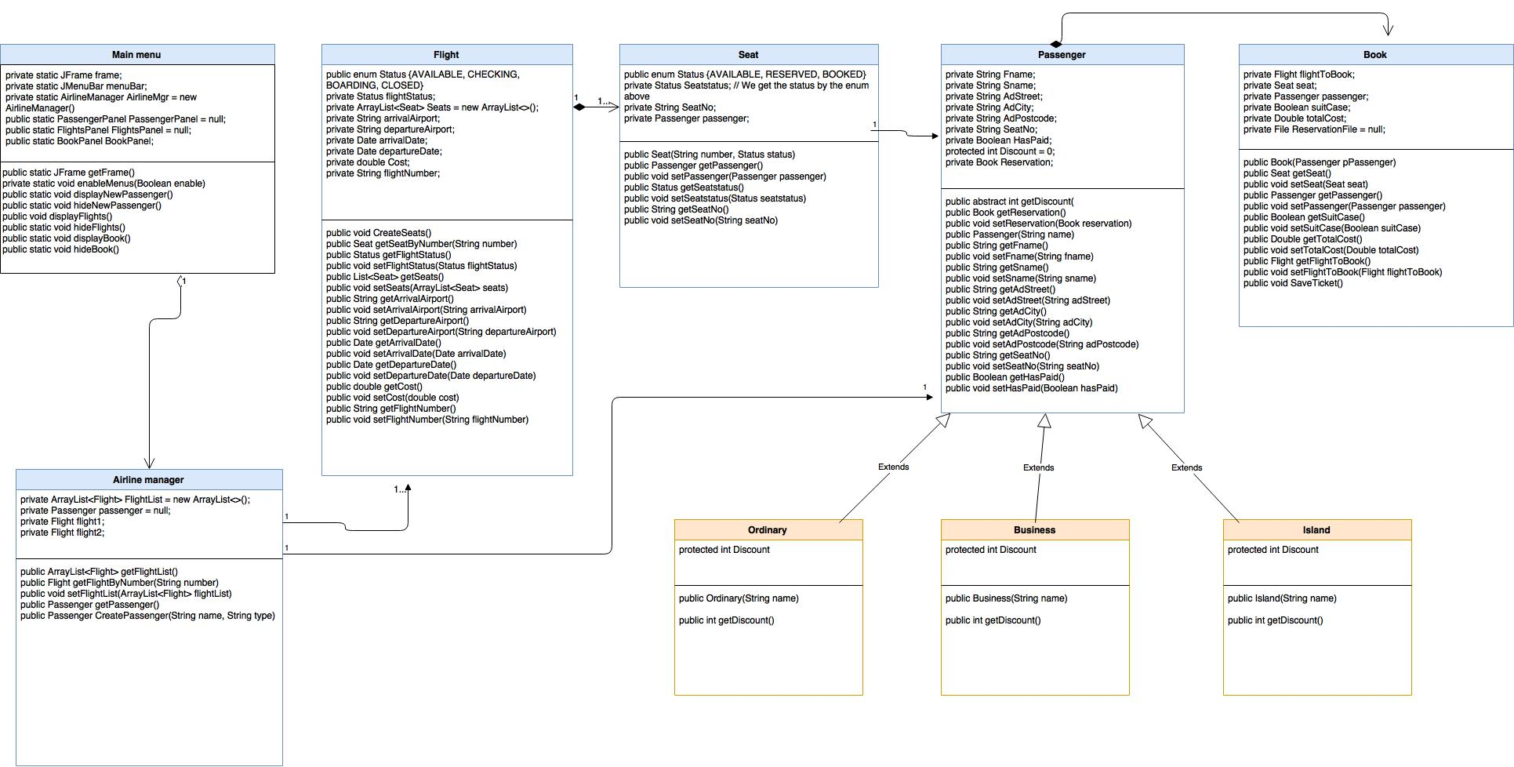

List of classes used with a brief description of the purpose of each class

Class Passenger:
We create the object Passenger with its attributes.
There is a Boolean to check if the client has paid.
The variable Discount is protected because it is going to be overwritten in the extended subclasses Ordinary, Business and Island.
The private variable Book Reservation its declare in this
The method getDiscount is abstract because the extended classes have its won discount to apply, that’s polymorphism.

Class Ordinary, Business, and Island:
This 3 classes inherits from class Passenger.
We declare the discount on each class.
We get the name from superclass Passenger.

Class Seat:
We declare a public enum to select only one option out of the 3 possible(available, reserved, booked).
We assign a seat to each passenger, and declared its status.

Class Flight :
We declare all variables that have to do with the flight:
We add the seats to the plane on an arraylist, and return them by number.
We initialize every flight status as Available.
We create a method to return each seat by number with a for loop.

Class Airline manager:
This class contains the logics of the application.
We declare an array to add the flights.
We create 2 flights and set all the information.
The constructor creates 2 flights and add them to the array to find flight by number.
We create an if statement in order to create passenger with its type, ordinary, business and island.

Class Main:
It shows all the panels.

Class Book:
In this class we calculate costs and reserve flights

This is the main Screen in the application, the options you can select are:

Menu Passenger:
Add or edit Passenger

Add or edit Passenger Screen:
Add Passenger info:
Name , Surname, Street, City and post code.
Select Passenger type:
Ordinary, Island, Business.
When this option has been selected the label Discount will show the right percentage to be applied.

Cancel or OK option.
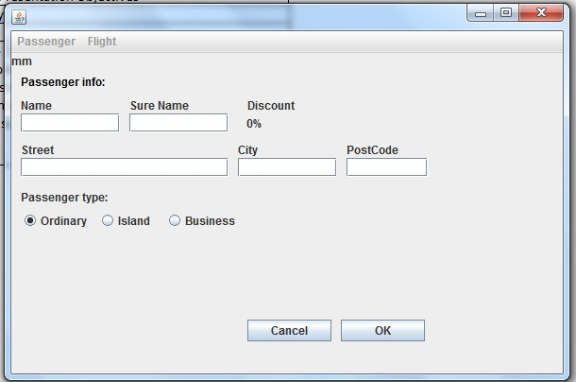

Menu flight:
Display Flights:
This screen allows you to check flights and select status.
You can select flight 123GF Skye-Glasgow or flight 473HR Arran-Glasgow.
It show you the cost once selected the flight.
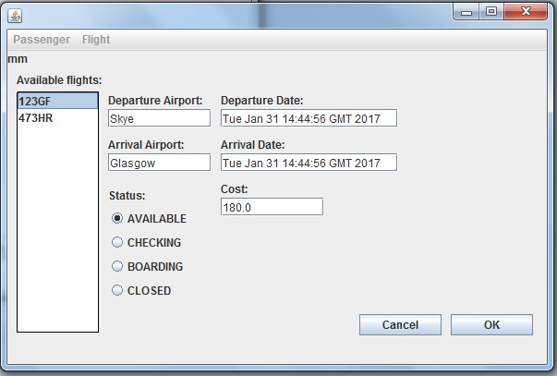

Book a Flight:
You can select flight 123GF Skye-Glasgow or flight 473HR Arran-Glasgow.
The information about airport and date will be displayed, and the flight status.
The passenger info will show the name and surname previously entered in passenger screen, and the type of flight.
On available seats we can display the seats still available in the flight and select them.
On cost it will show the flight cost, its discount, and the option to add a suitcase to our luggage and its price.
Total cost will show the final cost after the discount applied and Suitcase option.
We can confirm or cancel.
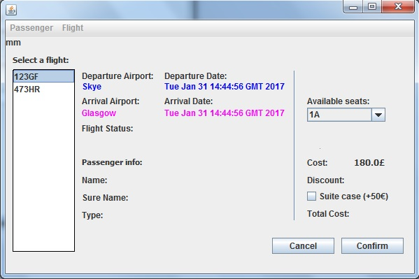

- Finally you must provide a checklist of the general programming requirements indicating whether or not these requirements were implemented in your code
General Programming Requirement | Tick if Achieved ()
The use of at least four classes (specify names of classes used) | X
Use of pre-defined classes and/or methods from the standard object library (list a couple of examples) | X
Use of Constructor methods | X
Use of setters and getters | X
Use of at least one overloaded method (indicate where implemented) | X
Implementing the use of parameter passing between objects | x
Implementing error handling using exceptions or pre-validation | X
Declaring and initialising Variables | X
Arithmetic and/or logical operators | X
Use of Control Structure | X
Use of at least two types of data structure implemented correctly (specify the types used) | X
The program code is commented appropriately throughout. | X

LINKS:
Enums:
http://stackoverflow.com/questions/3267520/declare-enum-variable-in-java-bean
http://www.aprenderaprogramar.com/index.php?option=com_content&view=article&id=648:enumerados-como-clases-enum-en-java-constructores-metodo-values-ejercicio-ejemplo-resuelto-cu00682b&catid=68:curso-aprender-programacion-java-desde-cero&Itemid=188

Factory:
http://www.arquitecturajava.com/usando-el-patron-factory/
http://jmperezramos.net/programacion/patron-factory-method-metodo-de-factorias/

Jpane:
http://www.dreamincode.net/forums/topic/32350-help-with-jfilechooser-writing-to-txt-file/
inheritance:
http://stackoverflow.com/questions/6308178/what-is-the-main-difference-between-inheritance-and-polymorphism

Swing:
https://www.youtube.com/watch?v=r8Qiz9Bn1Ag
https://www.youtube.com/watch?v=dXPgpKZFl3s
https://www.youtube.com/watch?v=coK4jM5wvko&list=PLU8oAlHdN5BktAXdEVCLUYzvDyqRQJ2lk

I used the notes provided on the VLE, and book called head to JAVA.

